-Kahoot link “Learning English”:
https://kahoot.it/challenge/0955135?challenge-id=a8e9bf0a-b616-4170-b840-f49e973862fd_1586436198037

Game Pin: 0955135

*I think that with the link you don´t need the Game Pin, but just in case you need it here it is.

*When it says “enter nickname” you have to write your name, if it doesn´t allow you to enter, it is because it is used, you can write something similar: for example your name and your favorite number (Julio7).

- https://www.mundoprimaria.com/juegos-educativos/juegos-de-ingles/3er-ciclo-grammar

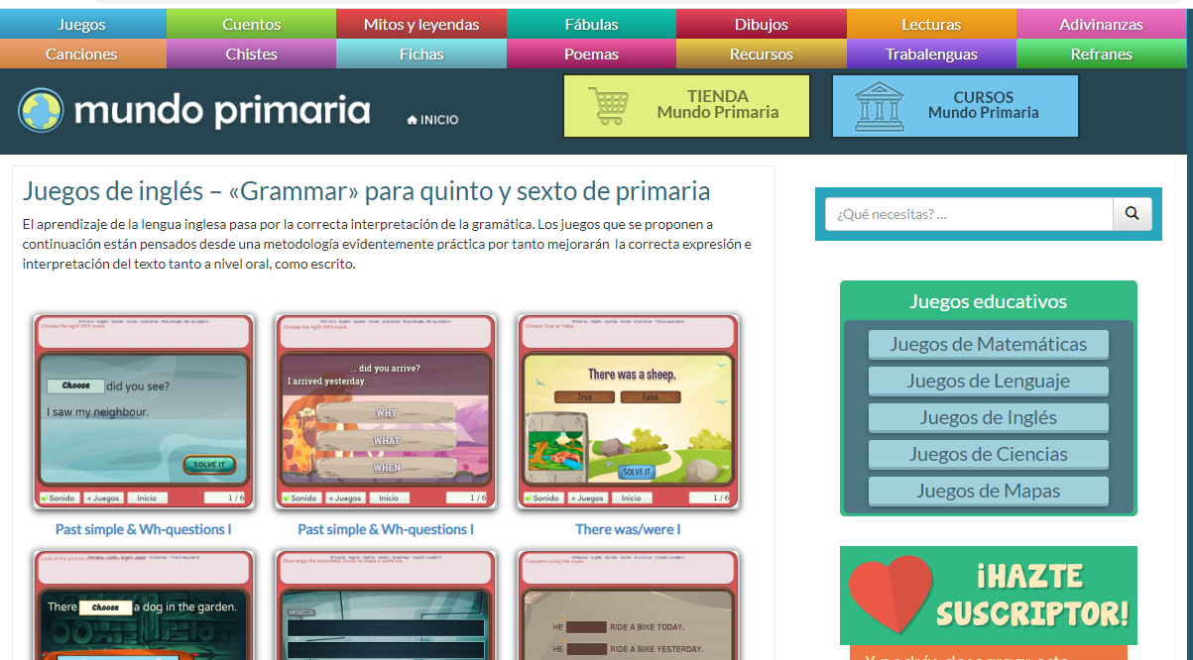

- http://www.cristic.com/3o-y-4o-de-primaria/

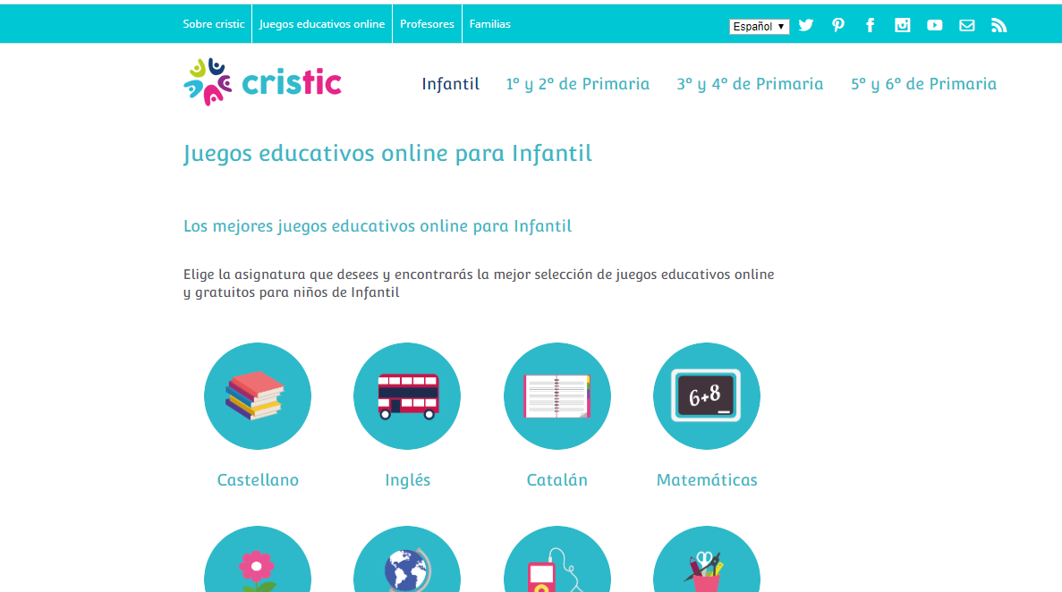

- https://www.englishactivities.net/es/temas-en-ingl%C3%A9s

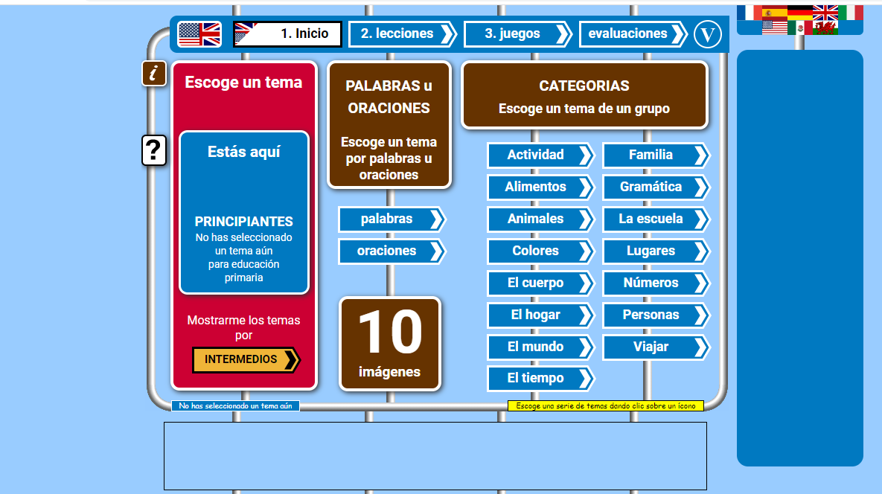

- http://www.saberingles.com.ar/

