THE SEASONS OF THE YEAR AND THEIR COLORS.

- Look at the following video and know the seasons of the year.
The seasons of the year.

- Look at the next picture and answer the questions.

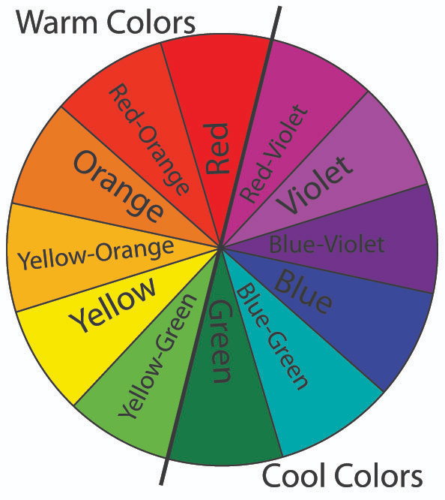

- Which colors are warm?

- Which colors are cool?

- Which one is your favourite and in which group is it?

- Paint the next parts of the picture with the appropriate color of each season and look at the difference between cool colors and warm colors. Write which seasons have cool colors and which warm.

- Winter:
- Autumn:
- Spring:
- Summer:

